Trying to Untangle The Confusion of Daily Briefings on the Shortage of PPE and How We In Our Industry, Laundry and Dry Cleaning, Could Help
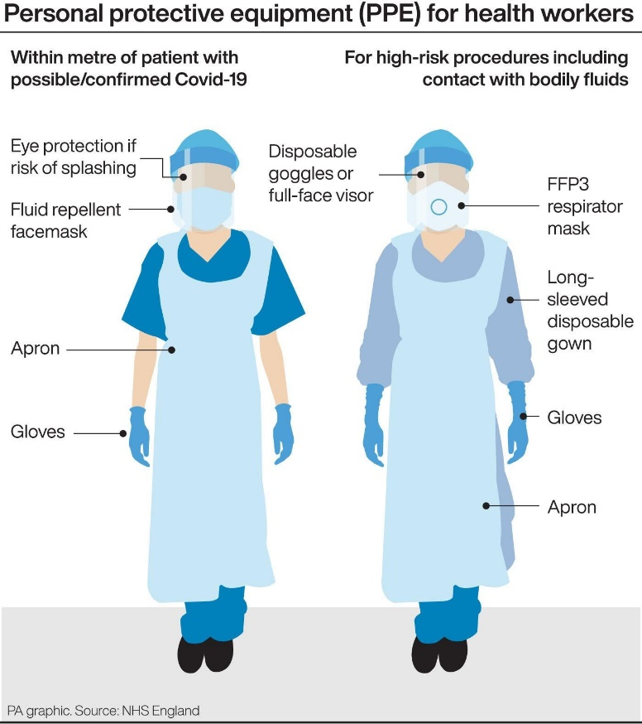
We have had a barrage of daily briefings since Britain first went in to lockdown in our efforts to avoid mass deaths and slowing the spread of the World Pandemic that is known as Covid -19.
In more recent times there has been much criticism of the shortage of PPE (Personal Protection Equipment) within the NHS and Care Homes.
There are many parts within the description of PPE for the health worker, especially for those on the front line looking after patients diagnosed with a Corona Virus such as Covid-19.
Pictured on the right is a selection listed and within these categories there are some variations, such as face masks, hats and Hospital Scrubs, a type of top and trouser bottom similar to a pyjama top and bottom, usually short sleeved and can be seen in the picture to the right being worn by the figure on the left hand side under the apron.
The Hospital Scrub uniform is washable and there is no reason why the country should currently have a shortage of these items, unless they are being sent for destruction via incineration, at the Hospitals. Laundries have experience of processing contaminated items and given the chance these could be reutilised and help to avoid the current shortage, but in practice much of the publicity of help by local manufacture is in fact for these types of garments.
The Long Sleeved Disposable Gown, shown under the apron on the right hand figure of the picture above, is the major item of long term shortage because the specification is just what it says for one use only and the specification provided to suppliers is available at the end of this article and within this a full specification for all Health service PPE is contained in the attached pdf Specification for Personal Protective Clothing (PPE) to include: Gowns, Surgical Face mask, Respirator masks, Eye Protection, Protective Coveralls.
Obviously, gifted with hindsight the long sleeved gowns, had they been specified as washable could now be re-cycled by laundering at higher temperatures and made suitable for re-use, therefore avoiding any shortage which is the current situation.
However, we are where we are, and what we can do to help the current situation is to commence to wash the single use gowns, which it is stated can be done up to three times before the gown becomes no longer protection against moisture splash. There are existing methods in use at laundry operations to monitor individual items for the number of wash cycles, and there are systems in place at many laundries to monitor the level, or standard, of hygiene achieved within the laundry cycle.
There are laundries, both within the Health Service and Private sector, that currently launder to these standards, and there are many Hospitality Laundry operations, currently not in use, that could, without much effort, be converted to process many thousands of tonnes per week of these types of garments, keeping these laundry companies in business and providing the NHS with much needed gowns.
Why does theNHS need so many? For those Health Service workers looking after Covid 19 patients they need a gown each time they go on shift, and then they need a clean gown when they have a break, which is usually after two and half hours, therefore it could mean one worker requiring four gowns per shift, plus all of the other disposable PPE items.
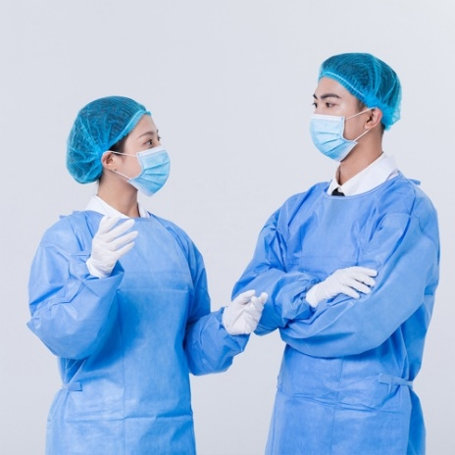
What else could we do?
The face mask – retail outlets, such as dry cleaners, could set themselves up to sanitise face masks and disposable goggles by a spray of an alcohol based sanitiser and sealing them afterwards in a polythene wrapper.
Washing machines, capable of providing a wash at 60°C for 10 minutes could be used to wash Hospital Scrubs on tight turn around times because finishing is just a tumble dry and fold after the process.
Yes, the business will need to adopt measures themselves to protect staff from picking up the virus from the contaminated items but that is not an impossible problem to solve.
The type of face (Nose and Mouth) masks seen being worn in the photograph on the left are sometimes made from paper, therefore not suitable for washing, but those made from textiles could be laundered and then reused, especially if we, the general public have to wear a mask covering our mouths and nose after the lockdown is over and we could provide an additional beneficial service to help to keep the replacement cycle lower. Textile Mouth and nose mask use could be extended by having a textile outer and tie strings with a disposable paper tissue type liner. The textile outer mask would need a laundry process but the inner liner of paper tissue would be a cheap supply alternative to prolong useful life.
Gloves and hats are disposable and not made to be suitable for any type of reprocessing.
If the general public are to wear a nose and mouth mask after the lockdown is over then we could keep the face mask on the right for NHS and Care Workers and then the face mask on the left could be used for the general public. If this sort of split is not acceptable due to availability then a different colour could be used for the general public to distinguish the difference.
Those dry cleaners with the solvent Perchloroethylene, with the knowledge from the 2019 Northumbria University Research, could offer a sanitising service for garments from patients diagnosed with the virus although they would have to segregate the way in which these items were accepted and sorted but in cleaning and finishing they would not present any problems in the process operation because the research proved there was no risk of cross contamination due to nature of the solvent.
In the twelve page pdf attachment (Specification for Personal Protective Clothing (PPE), Gowns, Surgical Face mask, Respirator masks, Eye Protection, Protective Coveralls) it can be seen that the gown is specified as single use and this is perhaps a weakness that at a future time needs to be addressed. A multi use manufactured item made from a textile could be washed after each wear and recycled in excess of fifty times and the limit on this could only be at a local level within a Hospital that failed to put a gown into a container for further laundering. It is expected that some education of staff to see the benefits of re-cycling, or putting it bluntly “to stop mixing up items just for the convenience of putting them into a bin for incineration”. In a laundry a modern single “Continuous Batch Washing Machine” (CBW) could be recycling textile gowns at the rate of at least 1.2 tonnes per hour and assuming each textile gown weighs half a kilo that is 2400 gowns per hour from each machine. Imagine at least over 90,000 gowns per week feeding in to the NHS for every CBW.
How many flights to Turkey did the RAF have to do to provide this quantity of gowns during the Pandemic?
90,000 less gowns to be disposed of, because they would then be recycled.
To me it is a no brainer!

